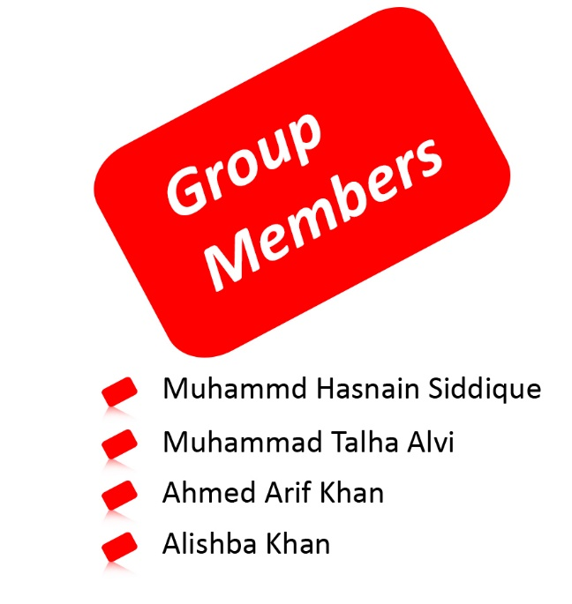­

E-PROJECT DOCUMENTATION

**ACKNOWLEDGEMENT**

I would like to acknowledge all those who have given me moral support and helped in making the project a success.

I wish to express my gratitude to e-Project Team at Head Office who guided and helped me. Also, I would like to express my gratitude to all the staff members of my center for not only providing me opportunity to work with them on this project, but also for their support and encouragement throughout the process.

I also express my sincere gratitude to e-Project Team from Aptech Head Office and my project guide at the organization for his valuable guidance and support for completion of this project.

**Table of Content**

|  |  |
| --- | --- |
| Content | Page No. |
| Introduction ---------------------------------------------------------------------------- | **03** |
| Requirement Specification ---------------------------------------------------------- | **04** |
| Descriptions of All Pages ------------------------------------------------------------ | **05** |
| Site Map -------------------------------------------------------------------------------- | **07** |
| Home Page------------------------------------------------------------------------------ | **08** |
| Market - -------------------------------------------------------------------------------- | **12** |
| About Us -------------------------------------------------------------------------------- | **16** |
| Contact Us ------------------------------------------------------------------------------ | **20** |

**INTRODUCTION**

This project is mainly about a web-page which advertises/sells cards of various occasions such as Birthday, Wedding, Anniversary, Eid and such.

You’ll find this web-page is easy on the easy and is fully-responsive on all its pages.

The entire web-site is made in a single HTML file, but you won’t notice that it is…

**REQUIREMENT SPECIFICATION**

The Web site is to be created based on the following requirements.

1) Home Page should contain logo of the site with proper sections and details of cards available.

2) The site should display a menu which will contain the options for brief introduction about the various categories and cards available, location of the shop and any other information if required.

3) The information should be categorized according to the brand names of the cards like if a User wants to see only “ARCHIES” cards or any other company’s cards then he/she can click on a Link/button/menu etc. and can see only that Brand cards.

4) Another category option for cards of different occasions, like ‘Birthday’,

‘Anniversary’ etc. should be created and accordingly the cards should be listed.

5) When a user selects any particular brand, a list of cards for that brand will be displayed.

6) A brief summary about individual cards should be displayed on the Web Page along with the price.

7) There should be a “Contact Us” page which will have the Address of the Store which is as follows and the mail address which when clicked will invoke the local mail client from where they can send an email.

**Descriptions of All Pages**

**Home:**

The first Page is of Home where animation are Rollover with Images of relative subjects are displayed about Cards with a dark mode switch and social icons on the right are displayed.

And a little description about the site with a contact info and then further below you find a link to the “market” page which will be hyperlinked as “Buy Cards” and below there’s also another link to “About Us” page which will be hyperlinked as “<<More Info”.  
And then below it you find the testimonials section where you can see feedback of our respected customer.  
Finally “Our Brands” section where the brands we deal in are listed.

**Market:**

This page’s first section is also similar to the home page with just the alteration of the title on the logo.  
In the second section you see list of all the cards and just above it there’s a card sorting algorithm where you can sort the cards by brand and categories such as “kasina Miller brand” and “birthday category“ and such..

**About Us:**

This page’s first section is also similar to the home page with just the alteration of the title on the logo.  
Which shows the complete and basic info about our organization. Below it are a few relative images.

**Contact Us:**

This page’s first section is also similar to the home page with just the alteration of the title on the logo.  
There you can see our entire list of our organization for your service.  
Any guidance or queries you can reach us throw are form and by mailing us on our Gmail.

**Footer:**

The footer appears on every page for the subscription to join our mailing list for any event or occasion and there is also our general contact info.

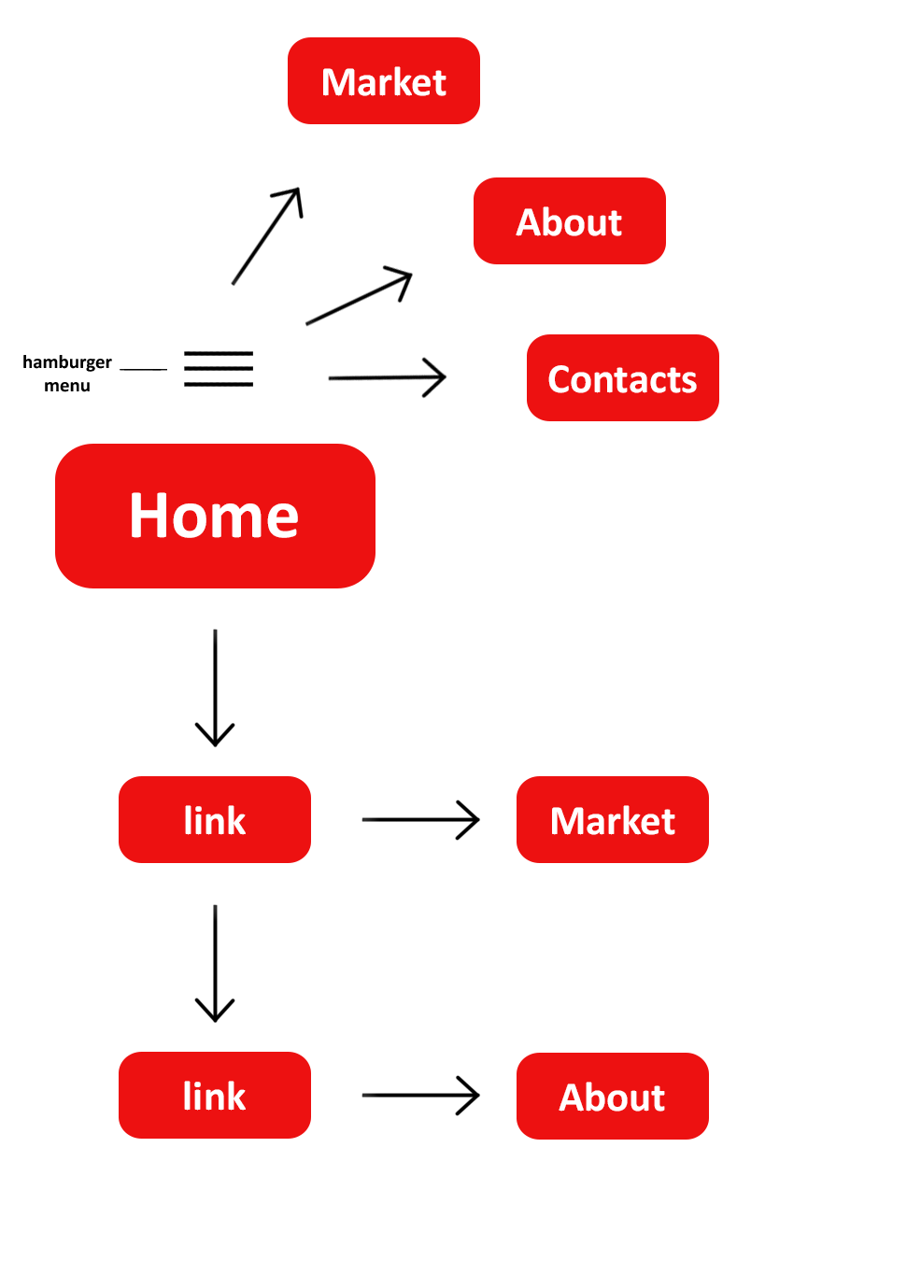

Site Map

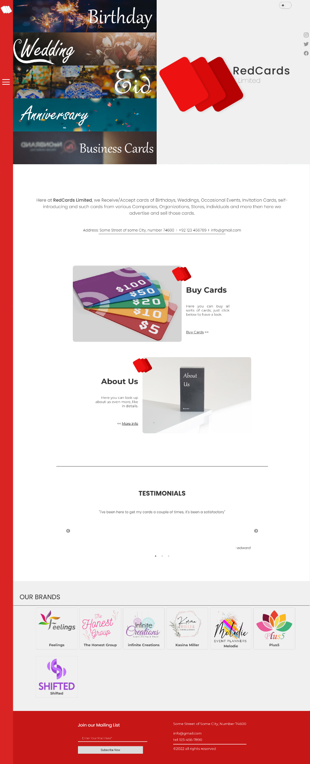

HomePage

ScreenShot

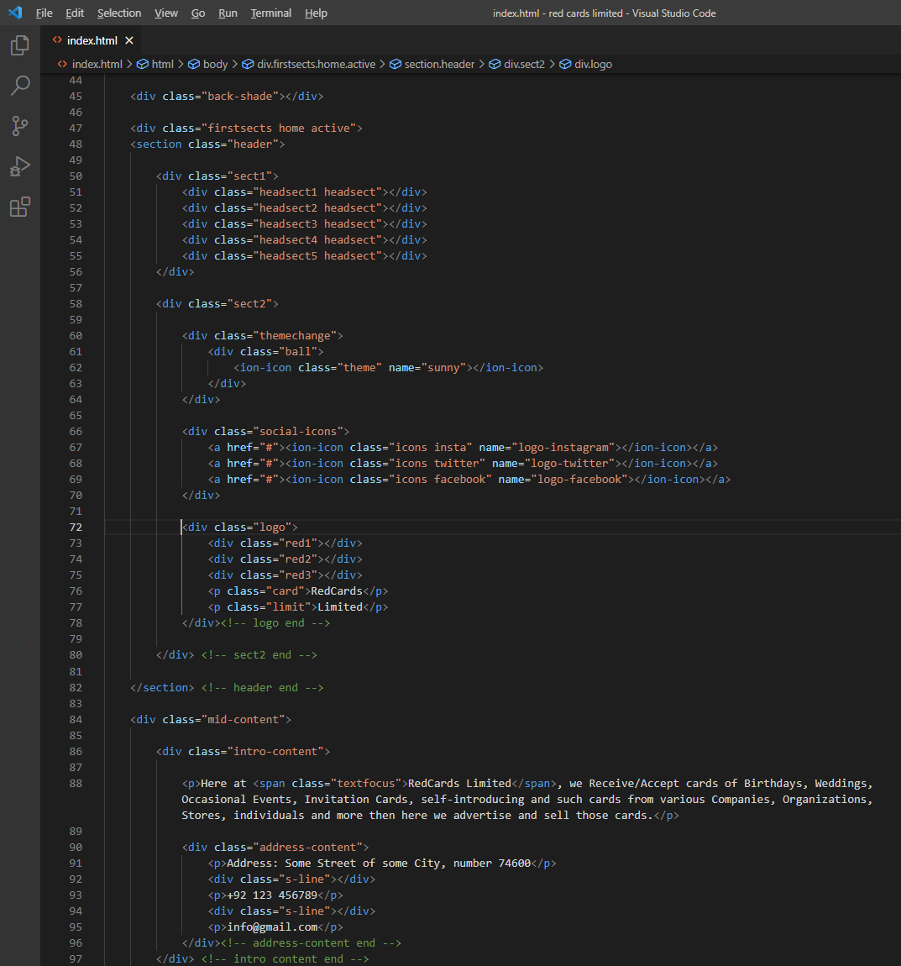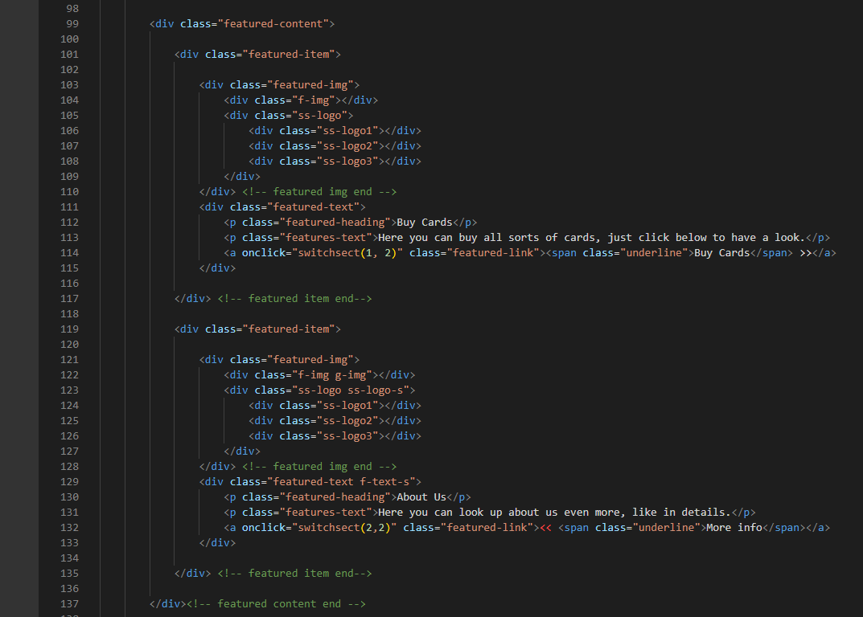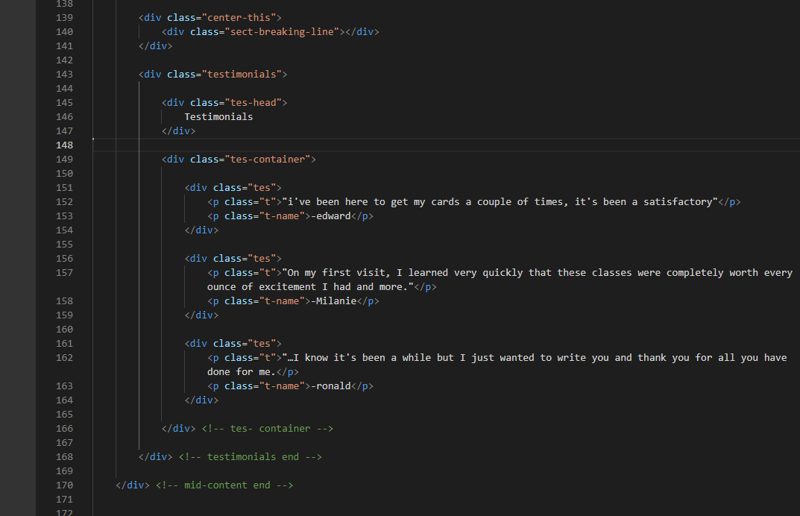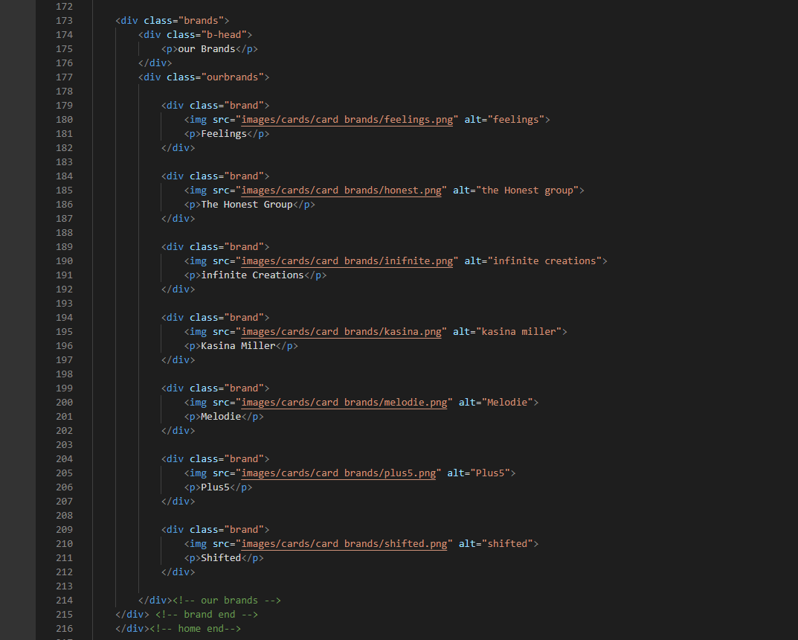

HomePage

Code

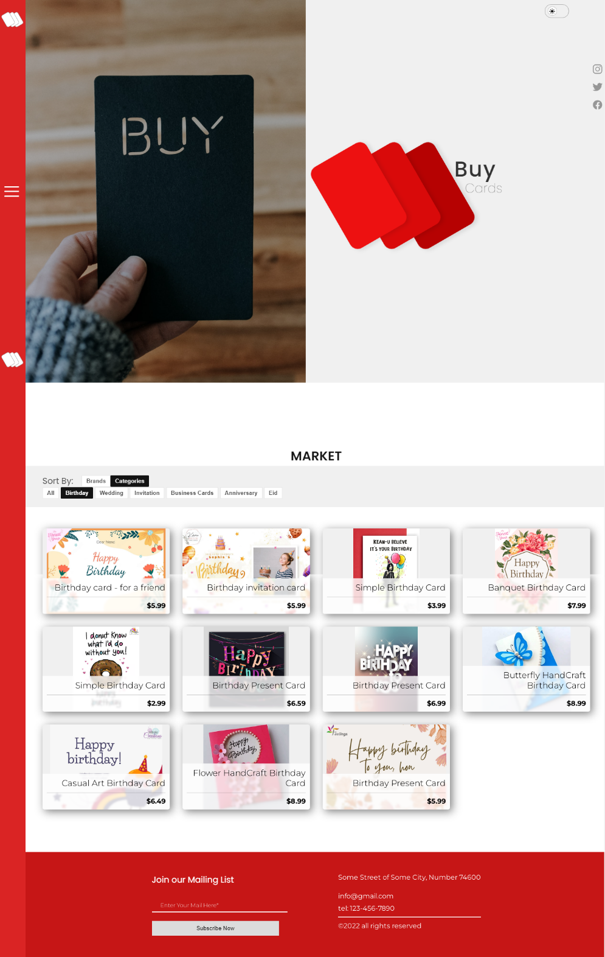

Market

Page

Screen

Shot

MarketPage

Code

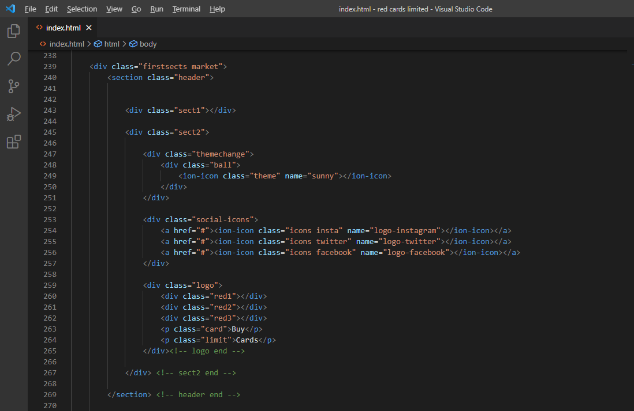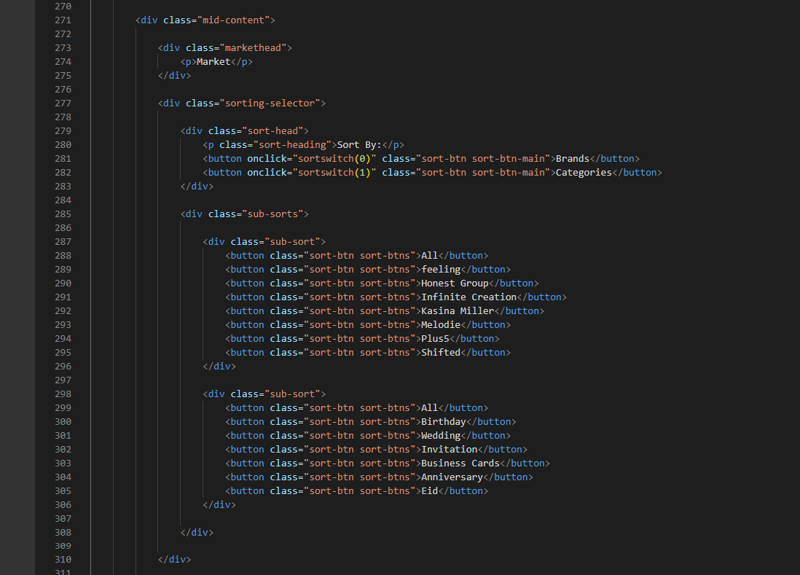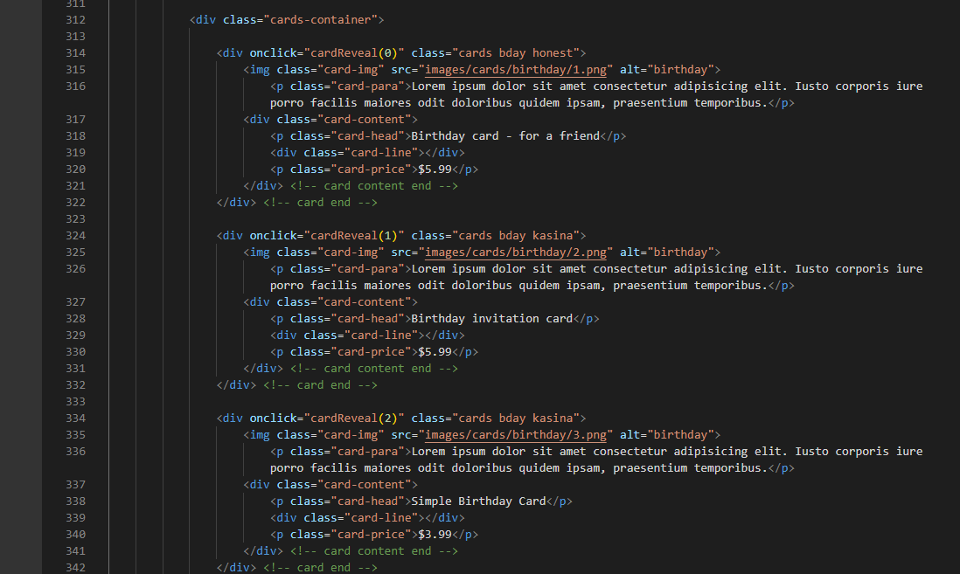

There are Exact 51 of these “cards” in the code, I’m not screenshoting every single one of those

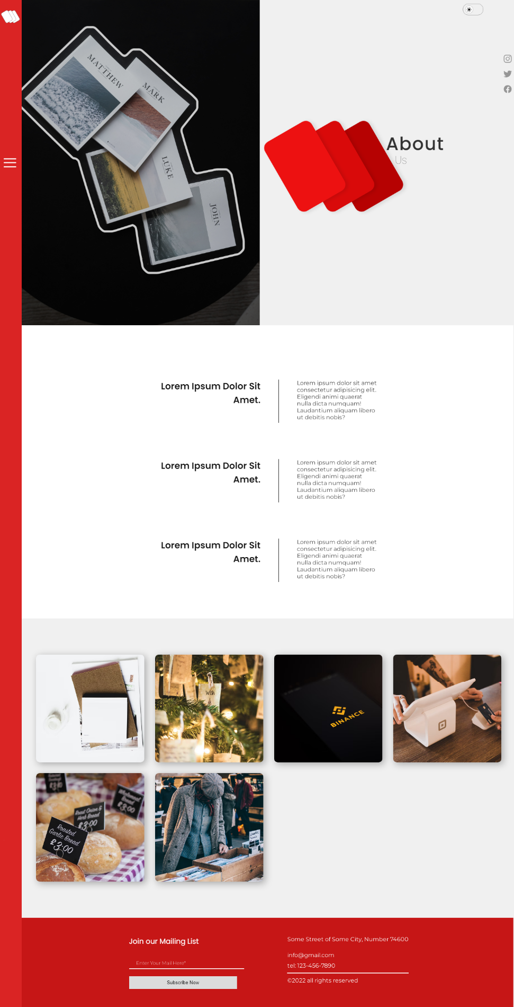

About

Page

Screen

Shot

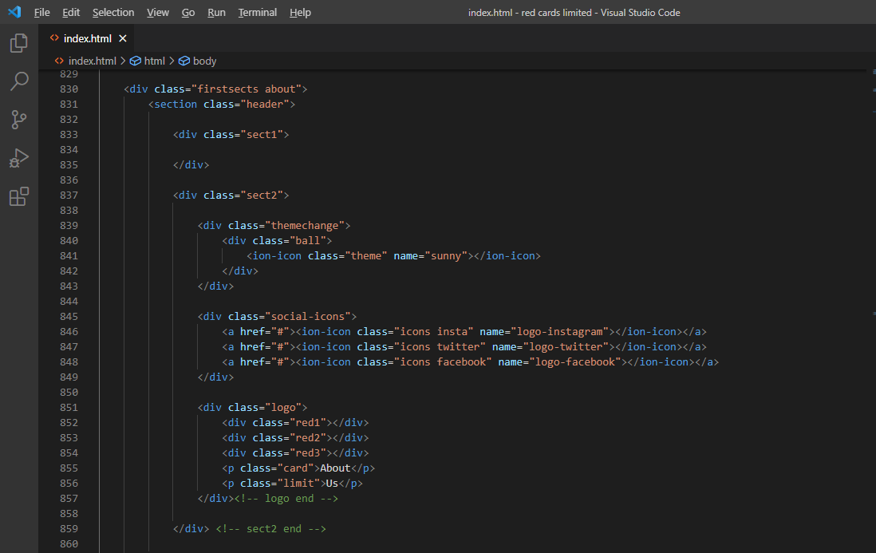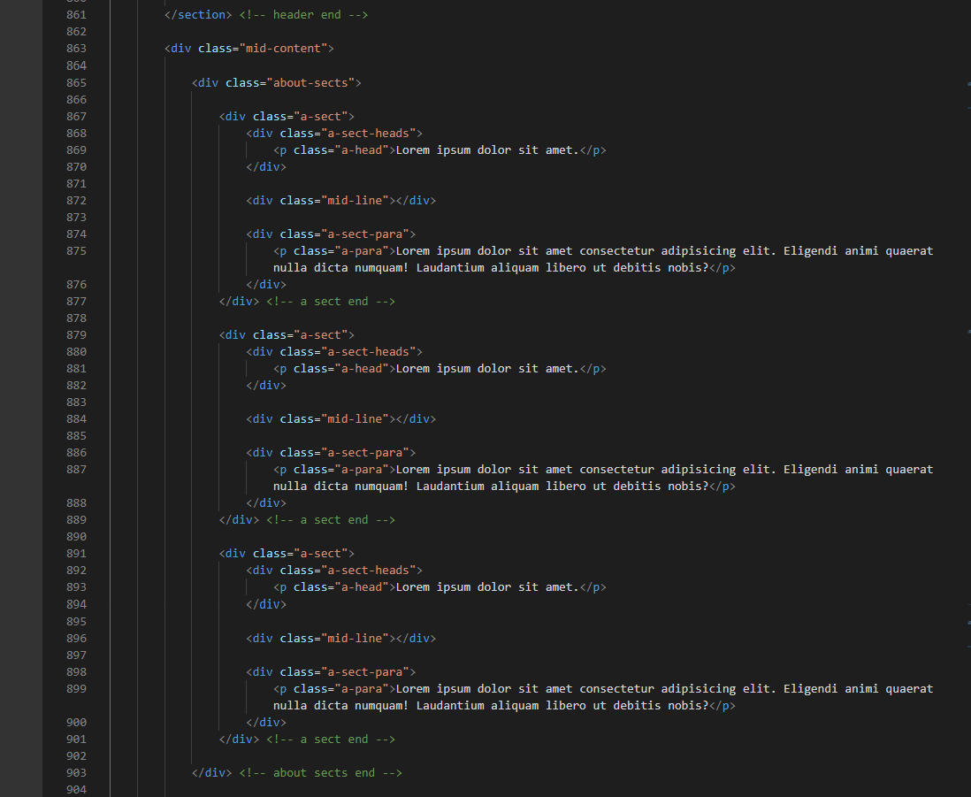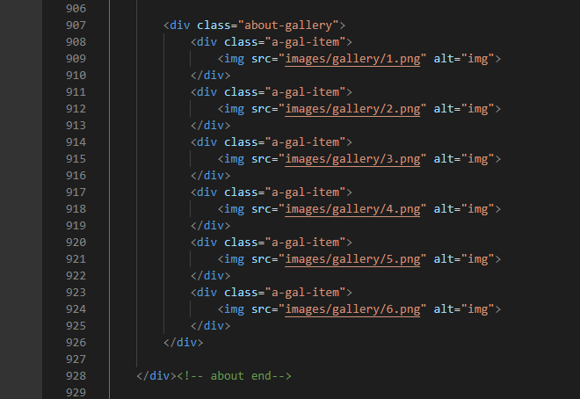

About Page

Code

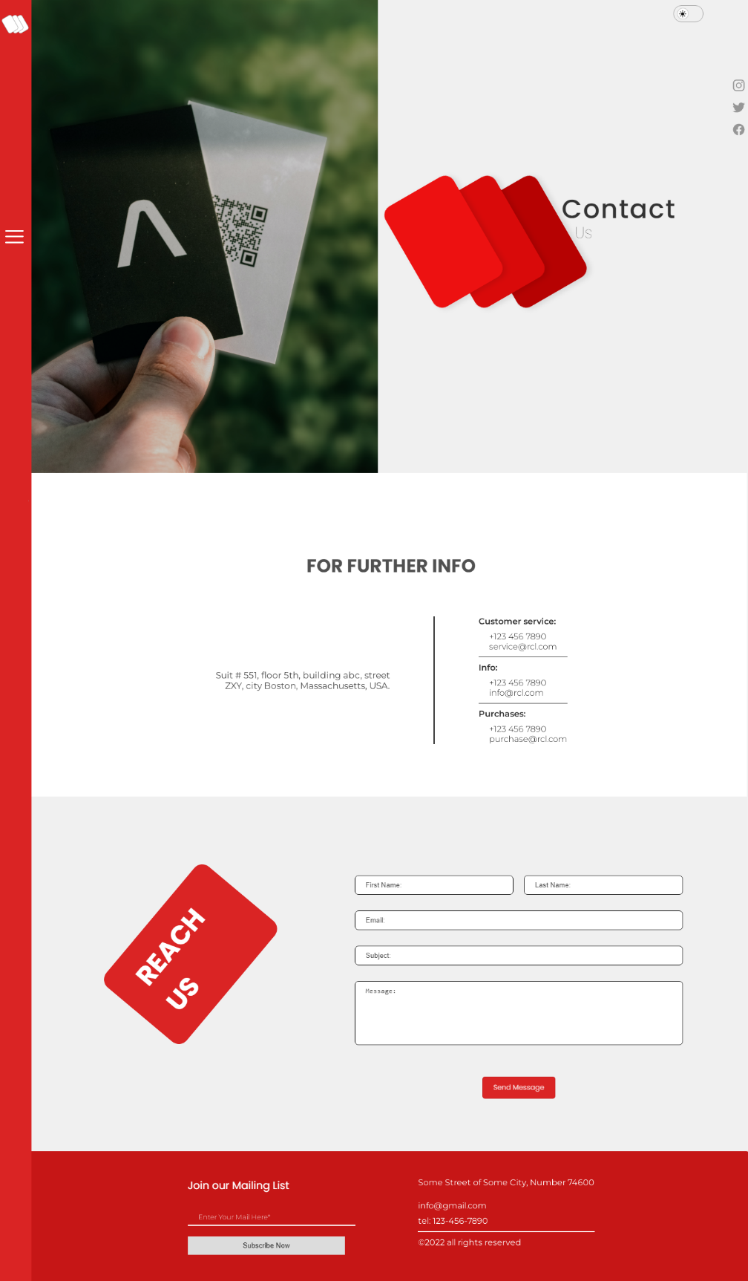

Contact

Page

Screen

Shot

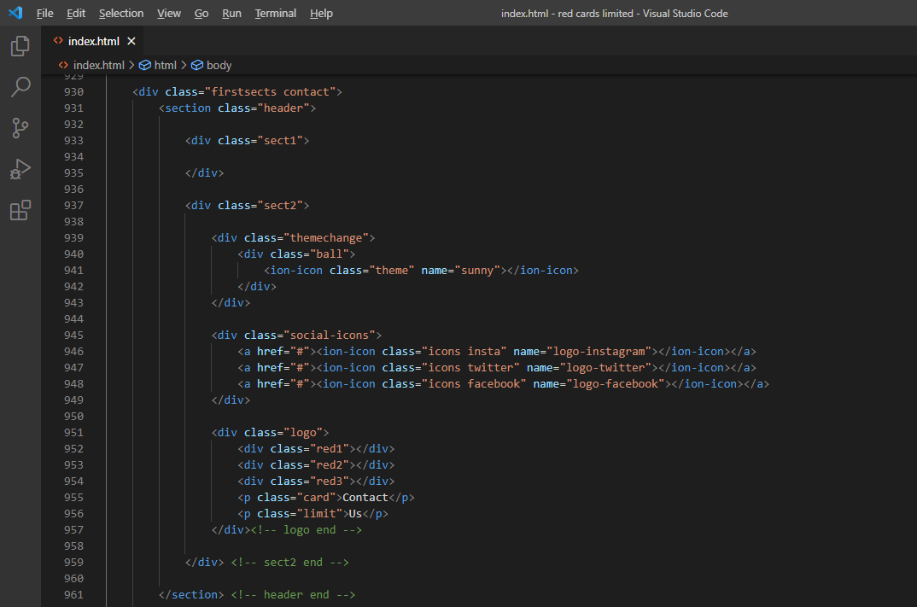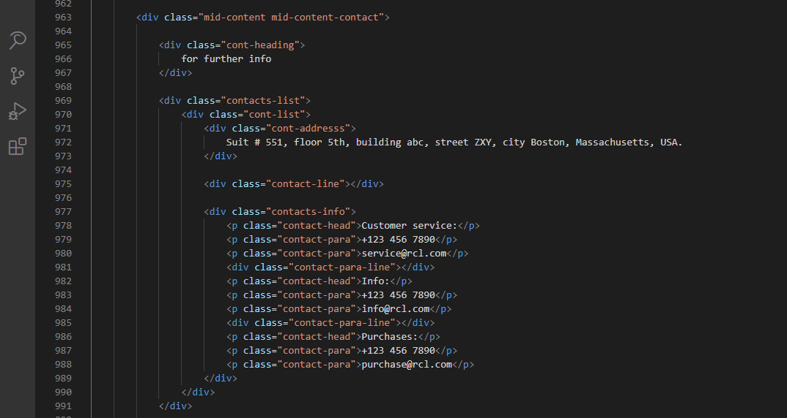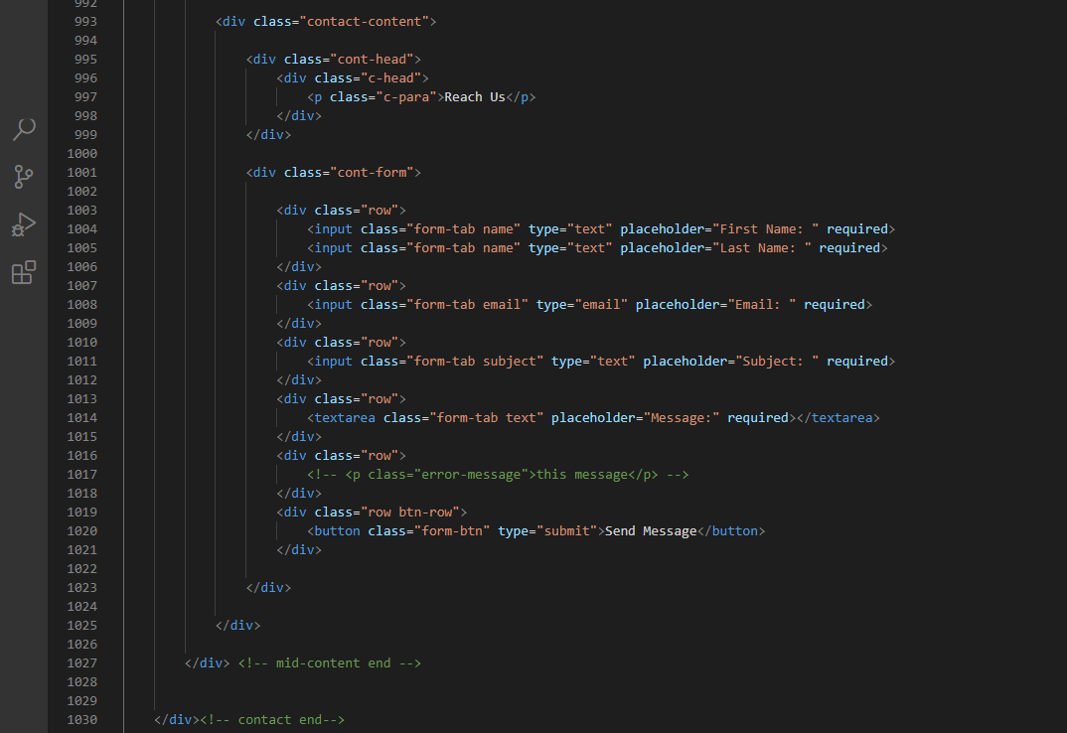

Contact Page

Code

This Concludes The Documentation of E-Project